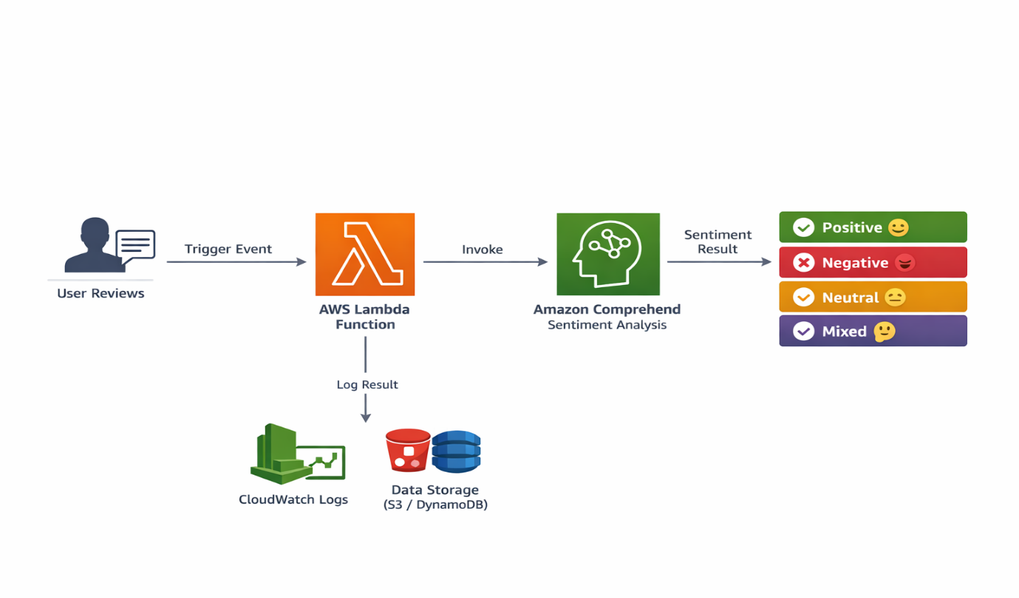

Created IAM Role for Lambda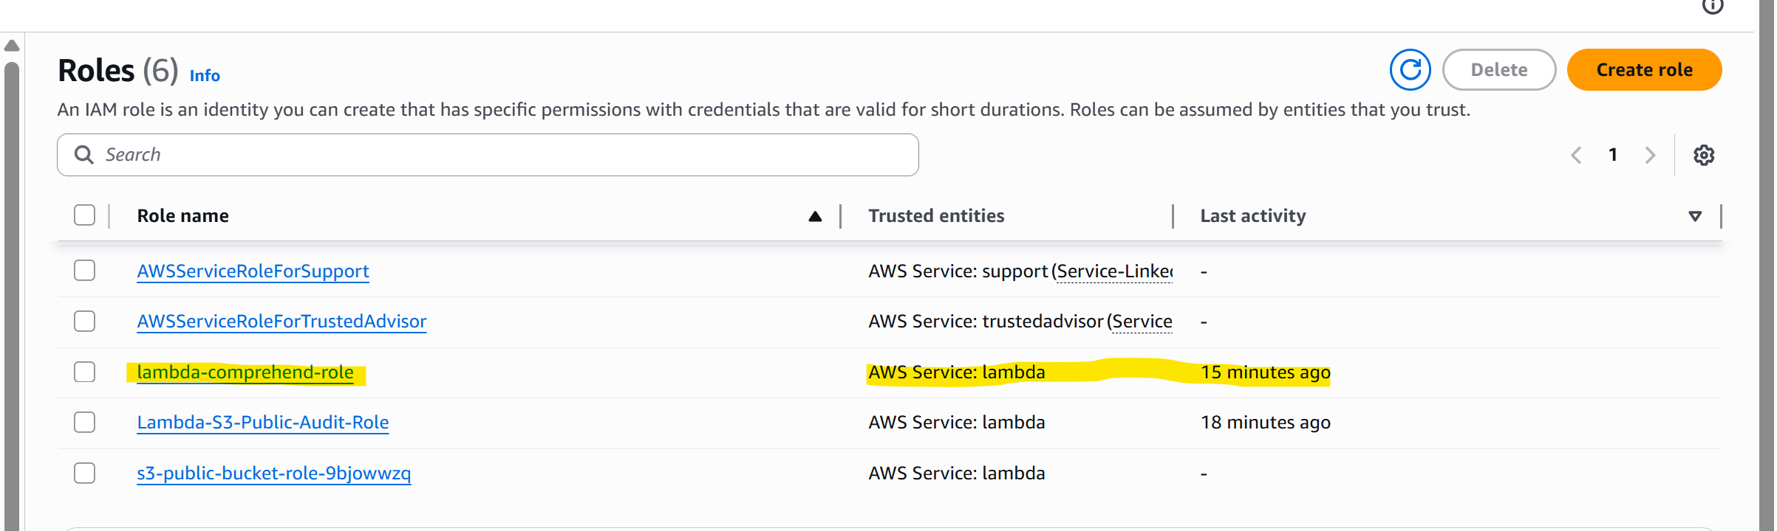
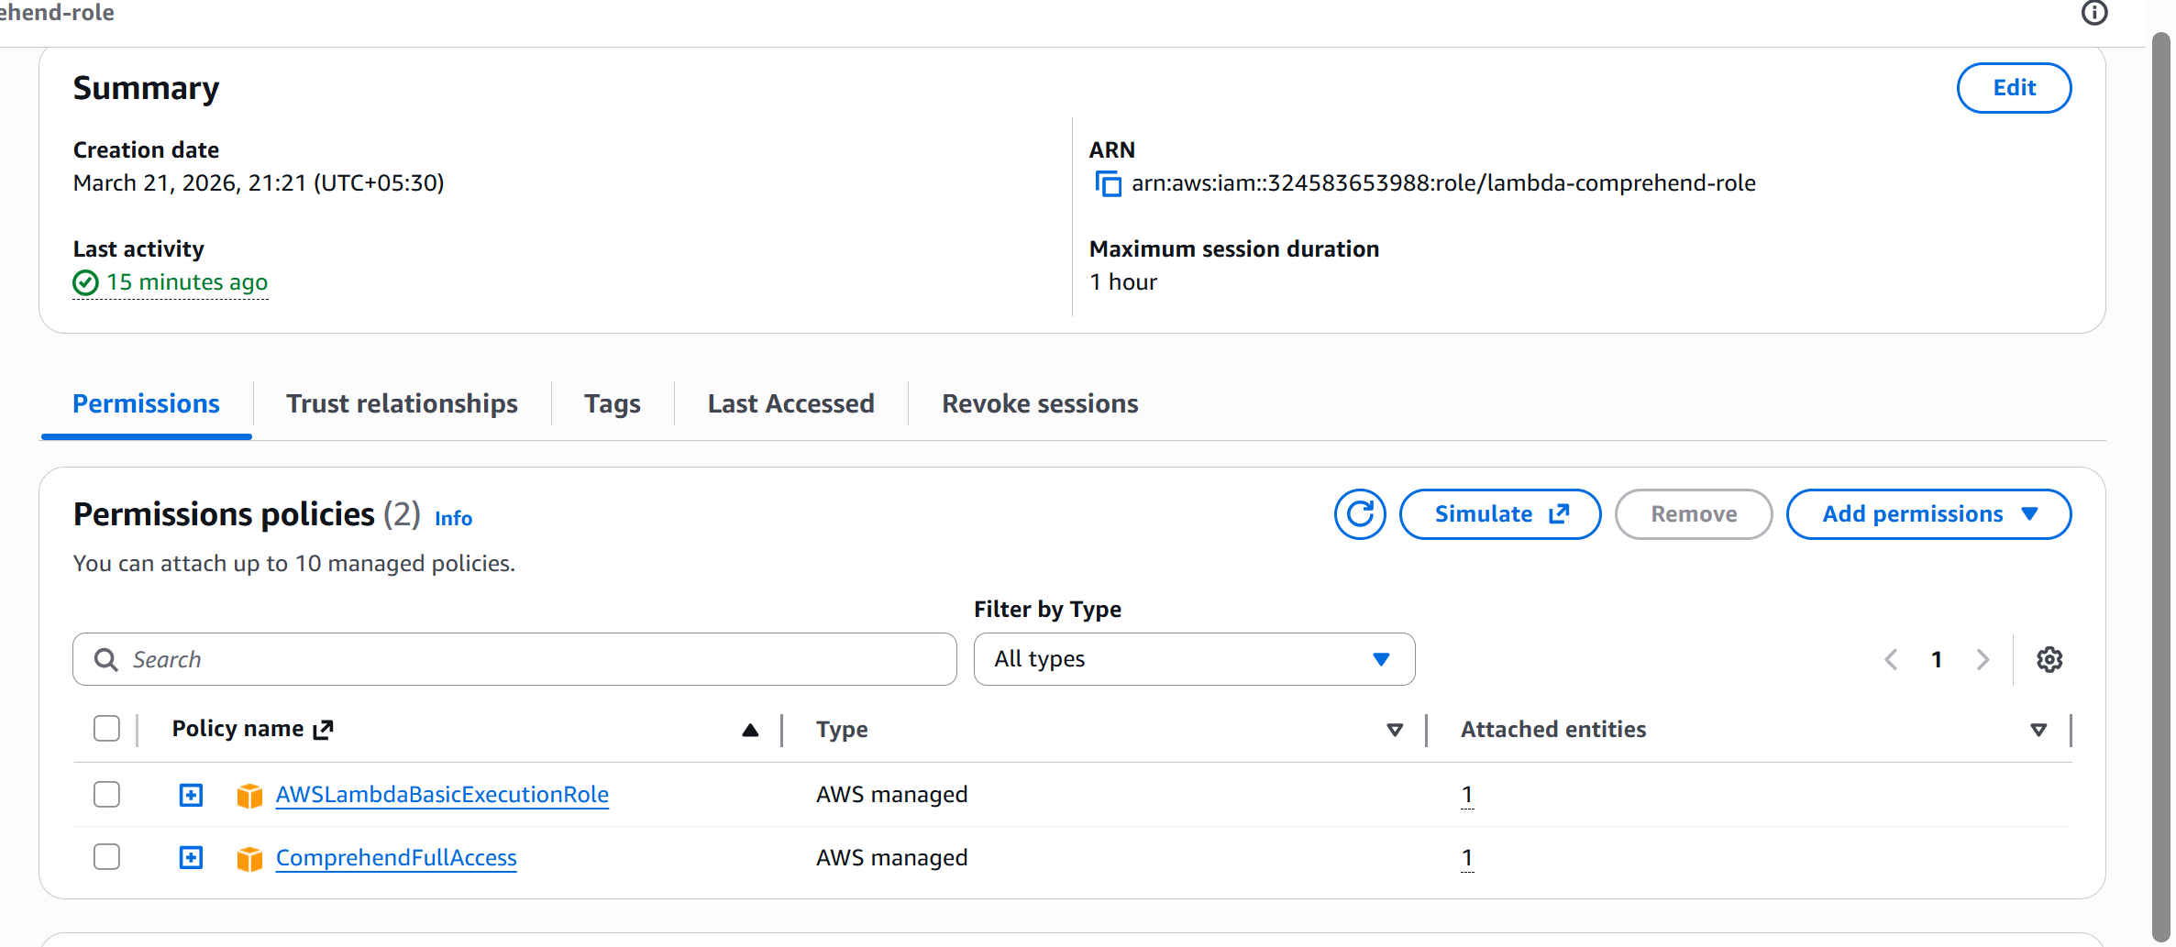

Created Lambda Function
1. Go to Lambda
- Open AWS Console → Lambda
- Click Create Function
2. Configure
- Function name: sentiment-analysis-function
- Runtime: latest Python
- Execution role:
👉 Choose Use existing role → select lambda-comprehend-role

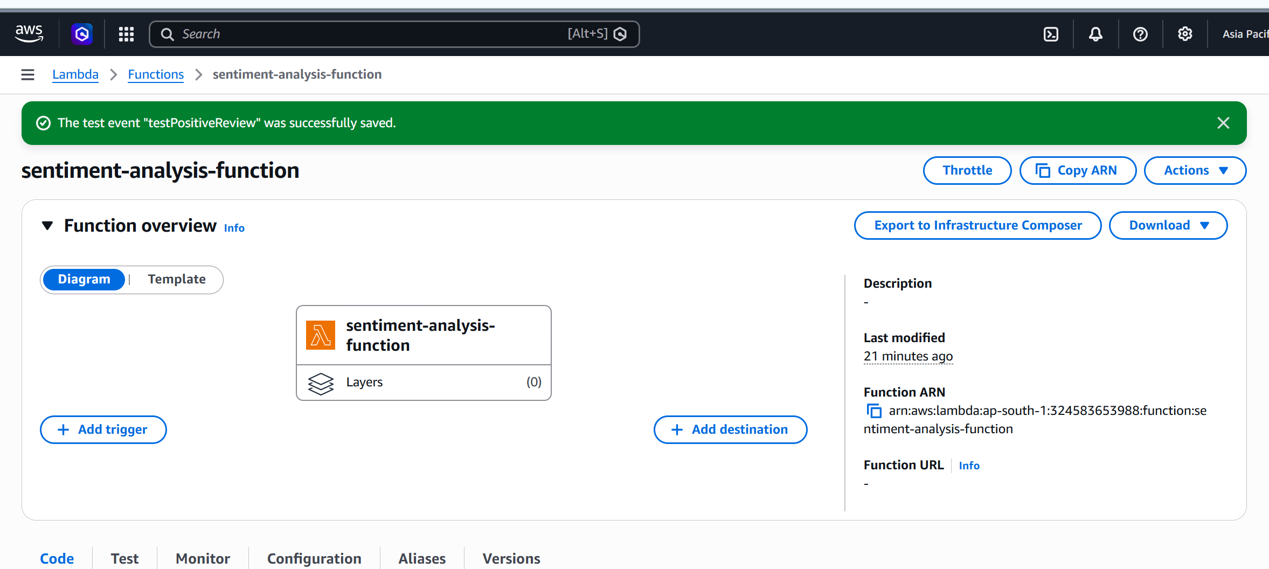
Added Python Code (Boto3 + Comprehend)
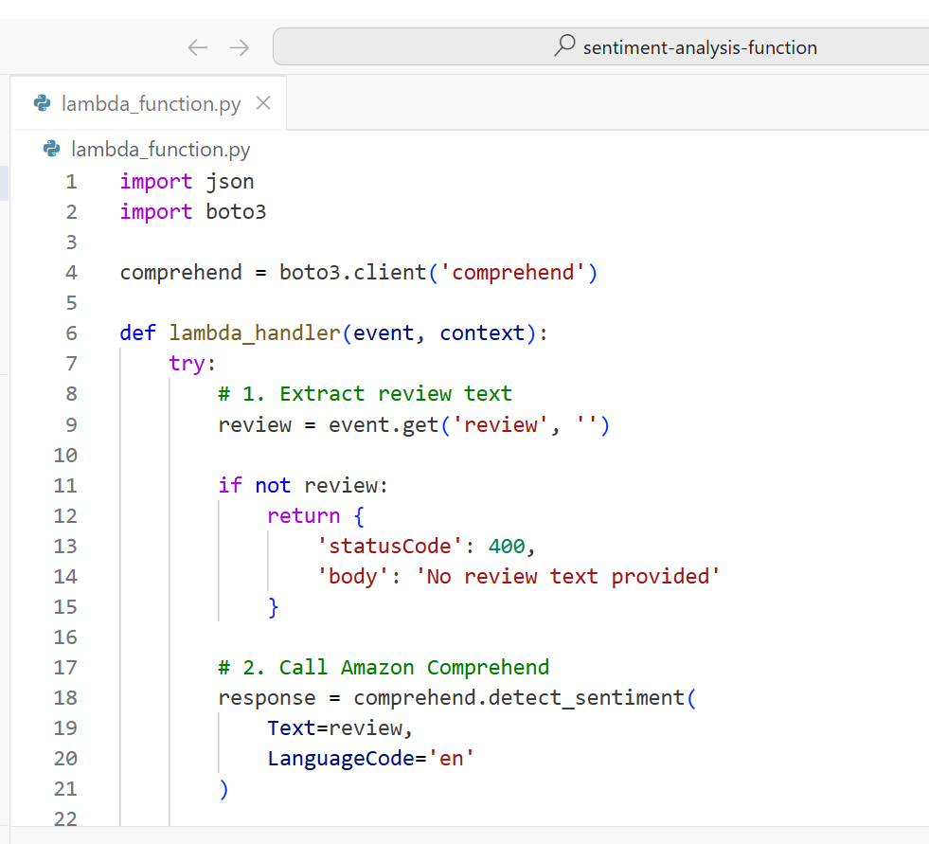
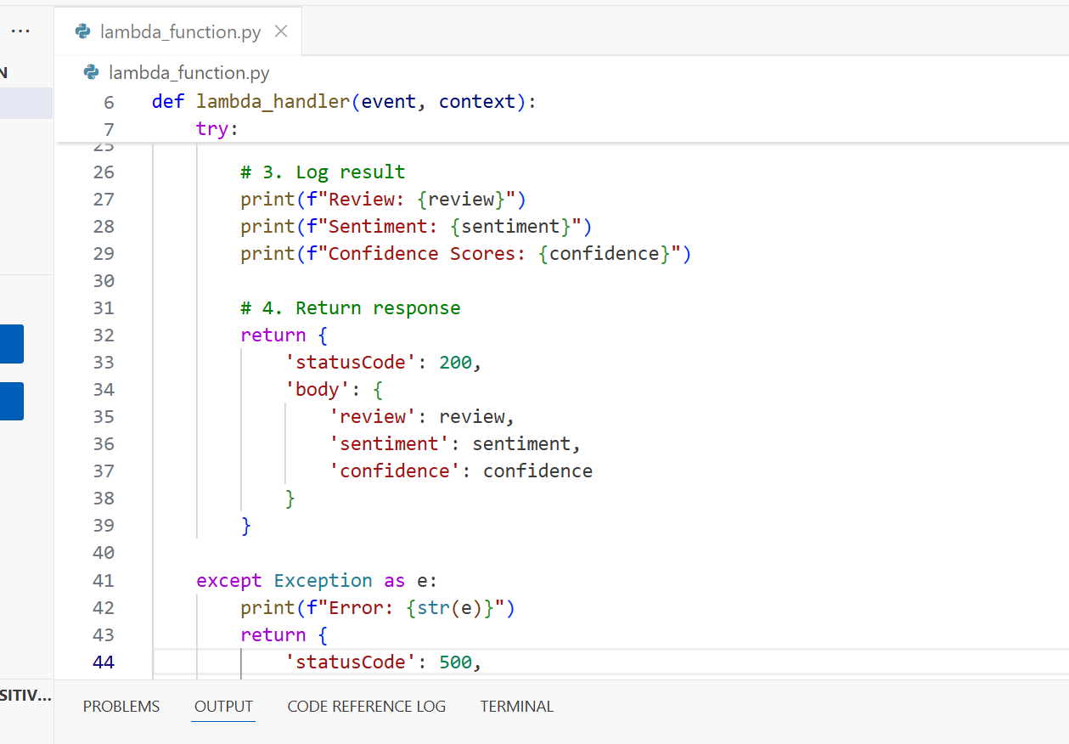

EXPECTED OUTPUT status code should be 200 but here it is showing 500 because Your account has NOT activated Amazon Comprehend yet as it is very chargeable but understood the concept and all steps are fine.

